📊 EURJPY (H1) — Decision
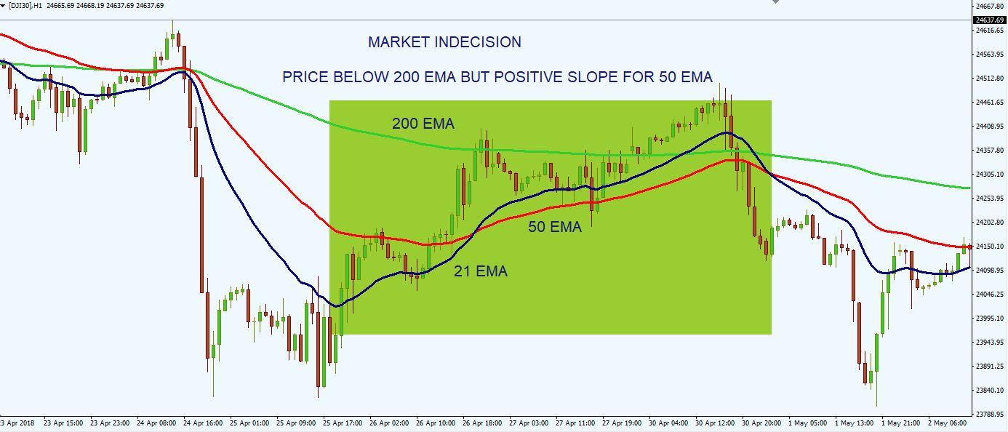
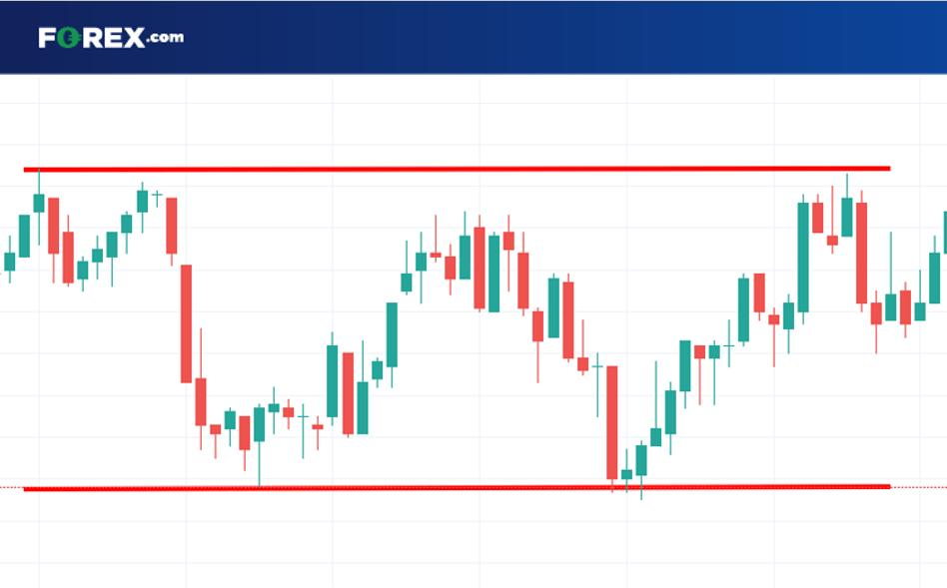
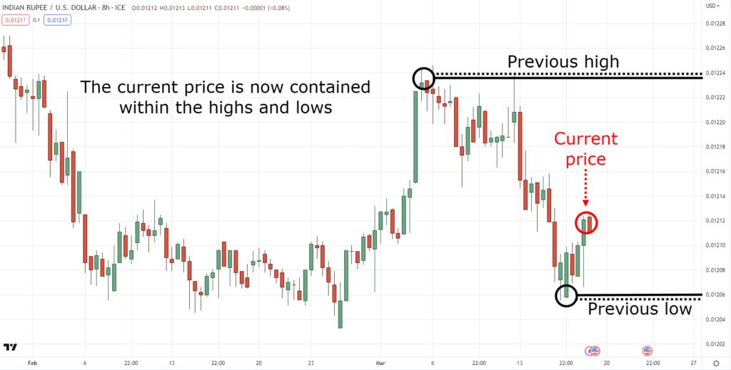
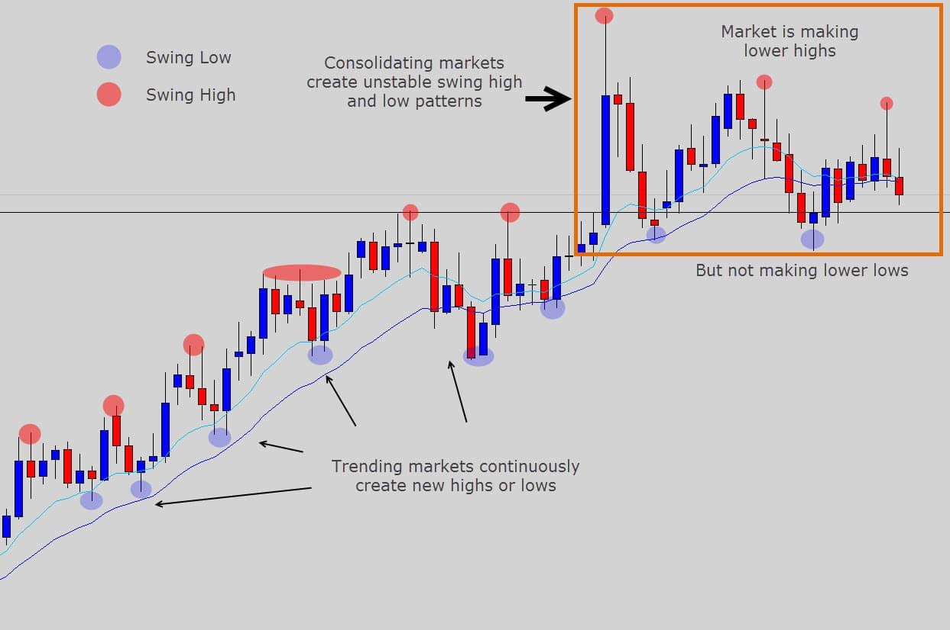
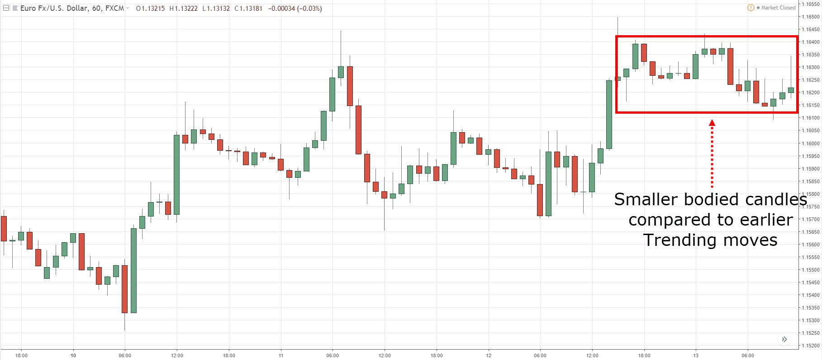
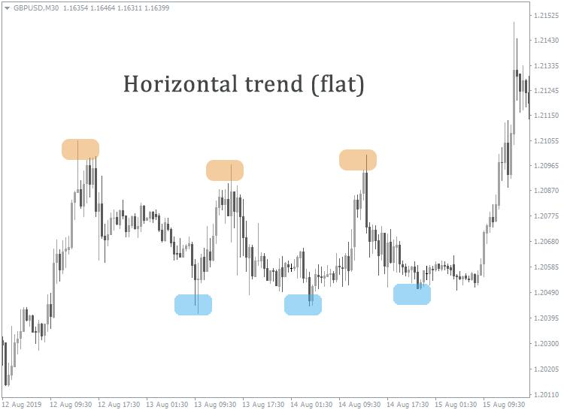

🔍 What I’m Seeing
- Price is moving sideways (range / chop)
- EMA 50 (red) and EMA 200 (blue) are very close
- No clear higher highs or lower lows
- Candles are mixed and overlapping
👉 This is a no-trend market

⚠️ Key Insight
This is the worst condition for:
- EMA crossover strategies ❌
- Trend-following bots ❌
👉 You’ll get fake signals (whipsaws) here

🎯 Smart Decision

❌ Best Move:
👉 NO TRADE

🟢 When to BUY
Only if:
- Price breaks above recent highs
- EMA 50 clearly moves above EMA 200
- Strong bullish candles return

🔴 When to SELL
Only if:
- Price breaks below support
- EMA 50 crosses below EMA 200
- Clear bearish structure forms

🧠 EA Perspective
Your EA should:
- ❌ Avoid trading now
- ✅ Wait for:
  - Trend formation
  - Or breakout from range

🔥 Final Answer
👉 Decision: NO TRADE
👉 Reason: Sideways / indecisive market

If you want next:
I can upgrade your EA with a “trend strength filter” so it automatically avoids these bad conditions (this will save you a lot of losses).

